**Project Part 4a**

Github Link:

**SQL script and screenshot that creates Database and Tables:**

CREATE DATABASE `ecommerce`

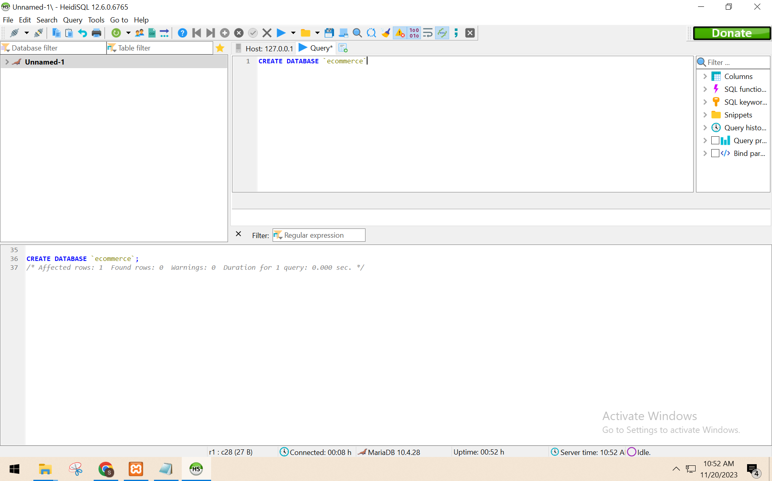

CREATE TABLE Supplier (

Supplier_Name varchar(50),

Contact_No varchar(50),

OrderNo varchar(50)

);

CREATE TABLE OrderTable (

OrderNo varchar(50),

Product_Name varchar(50),

Qty int,

Price float

);

CREATE TABLE Store (

StoreName varchar(50),

Address varchar(50),

Rating varchar(5)

);

CREATE TABLE Customer (

Customer_Name varchar(50),

Address varchar(50),

OrderNo varchar(50)

);

CREATE TABLE Payment (

Payment_id varchar(50),

Pay_by varchar(50),

method varchar(50),

Total_Amount float

);

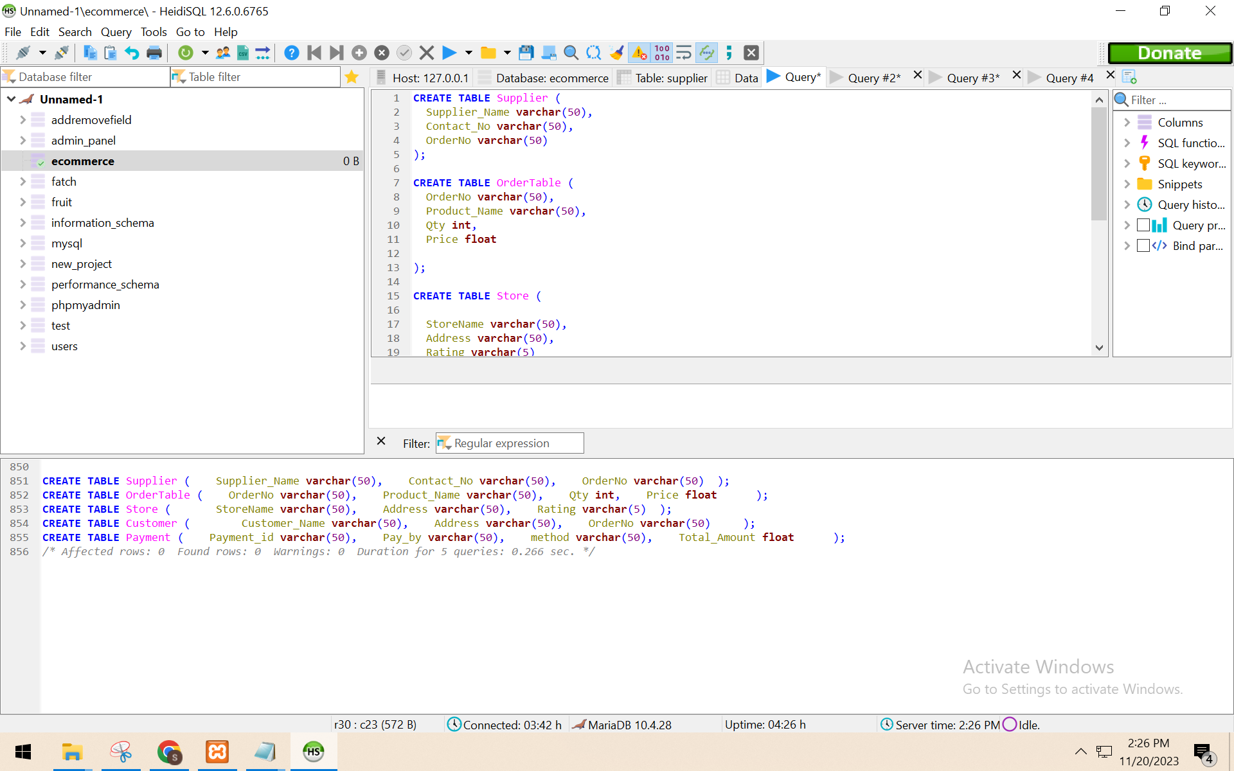

**SQL script that loads data files to tables:**

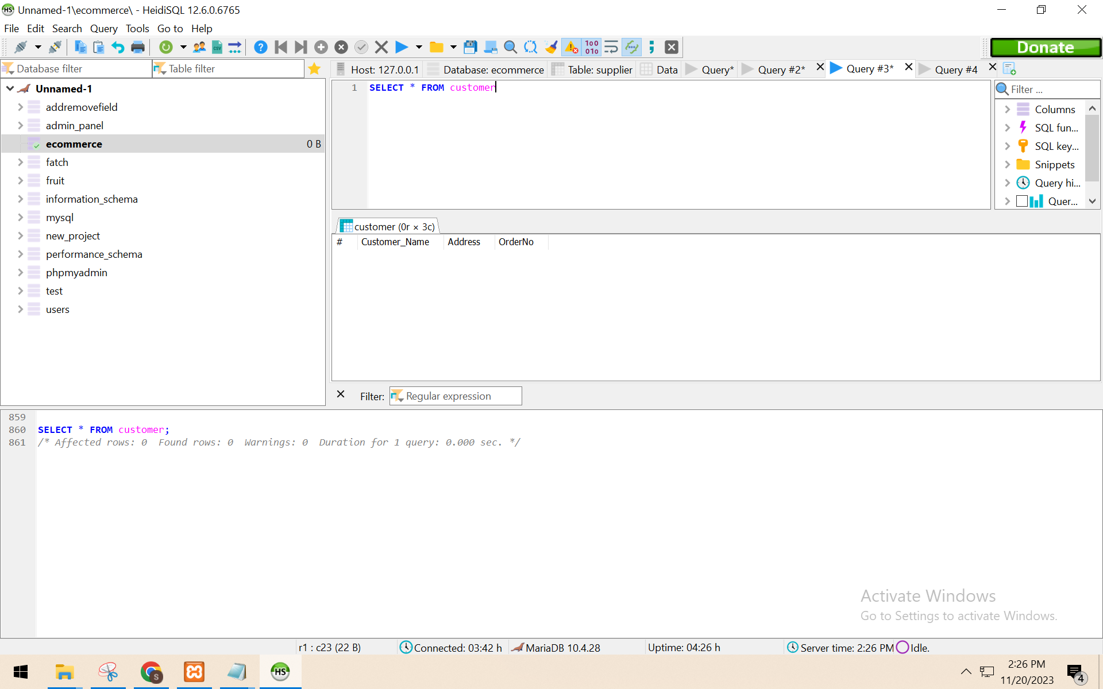

LOAD DATA LOCAL INFILE 'C:\\Users\\Admin\\Desktop\\VBOMMI~1\\week2\\Customer.csv'

INTO TABLE customer

FIELDS TERMINATED BY ',' ENCLOSED BY '"'

LINES TERMINATED BY '\r\n'

IGNORE 1 LINES

(`Customer_Name`, `Address`, `OrderNo`);

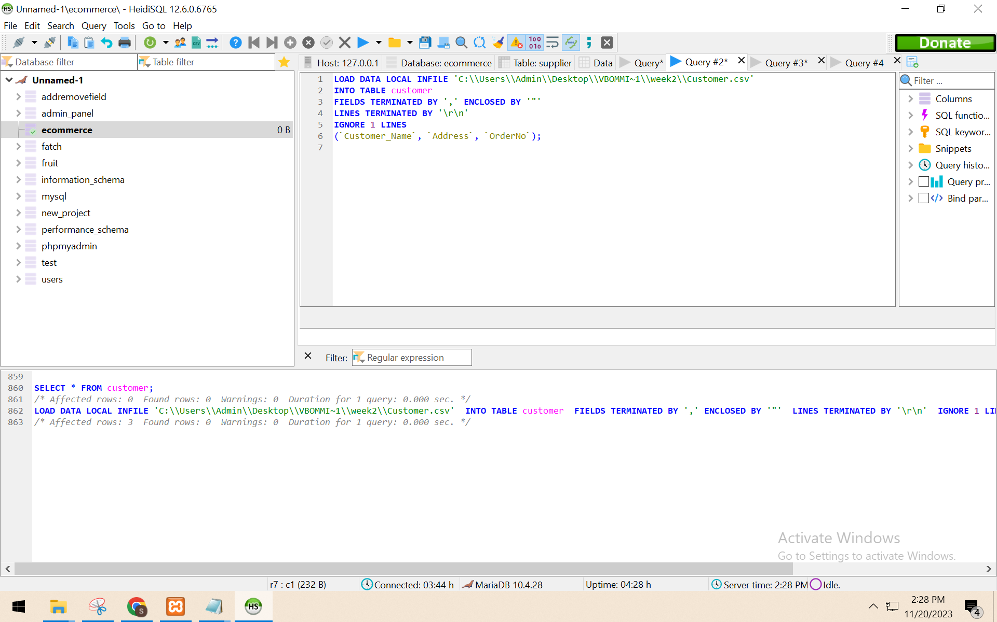

SELECT * FROM customer

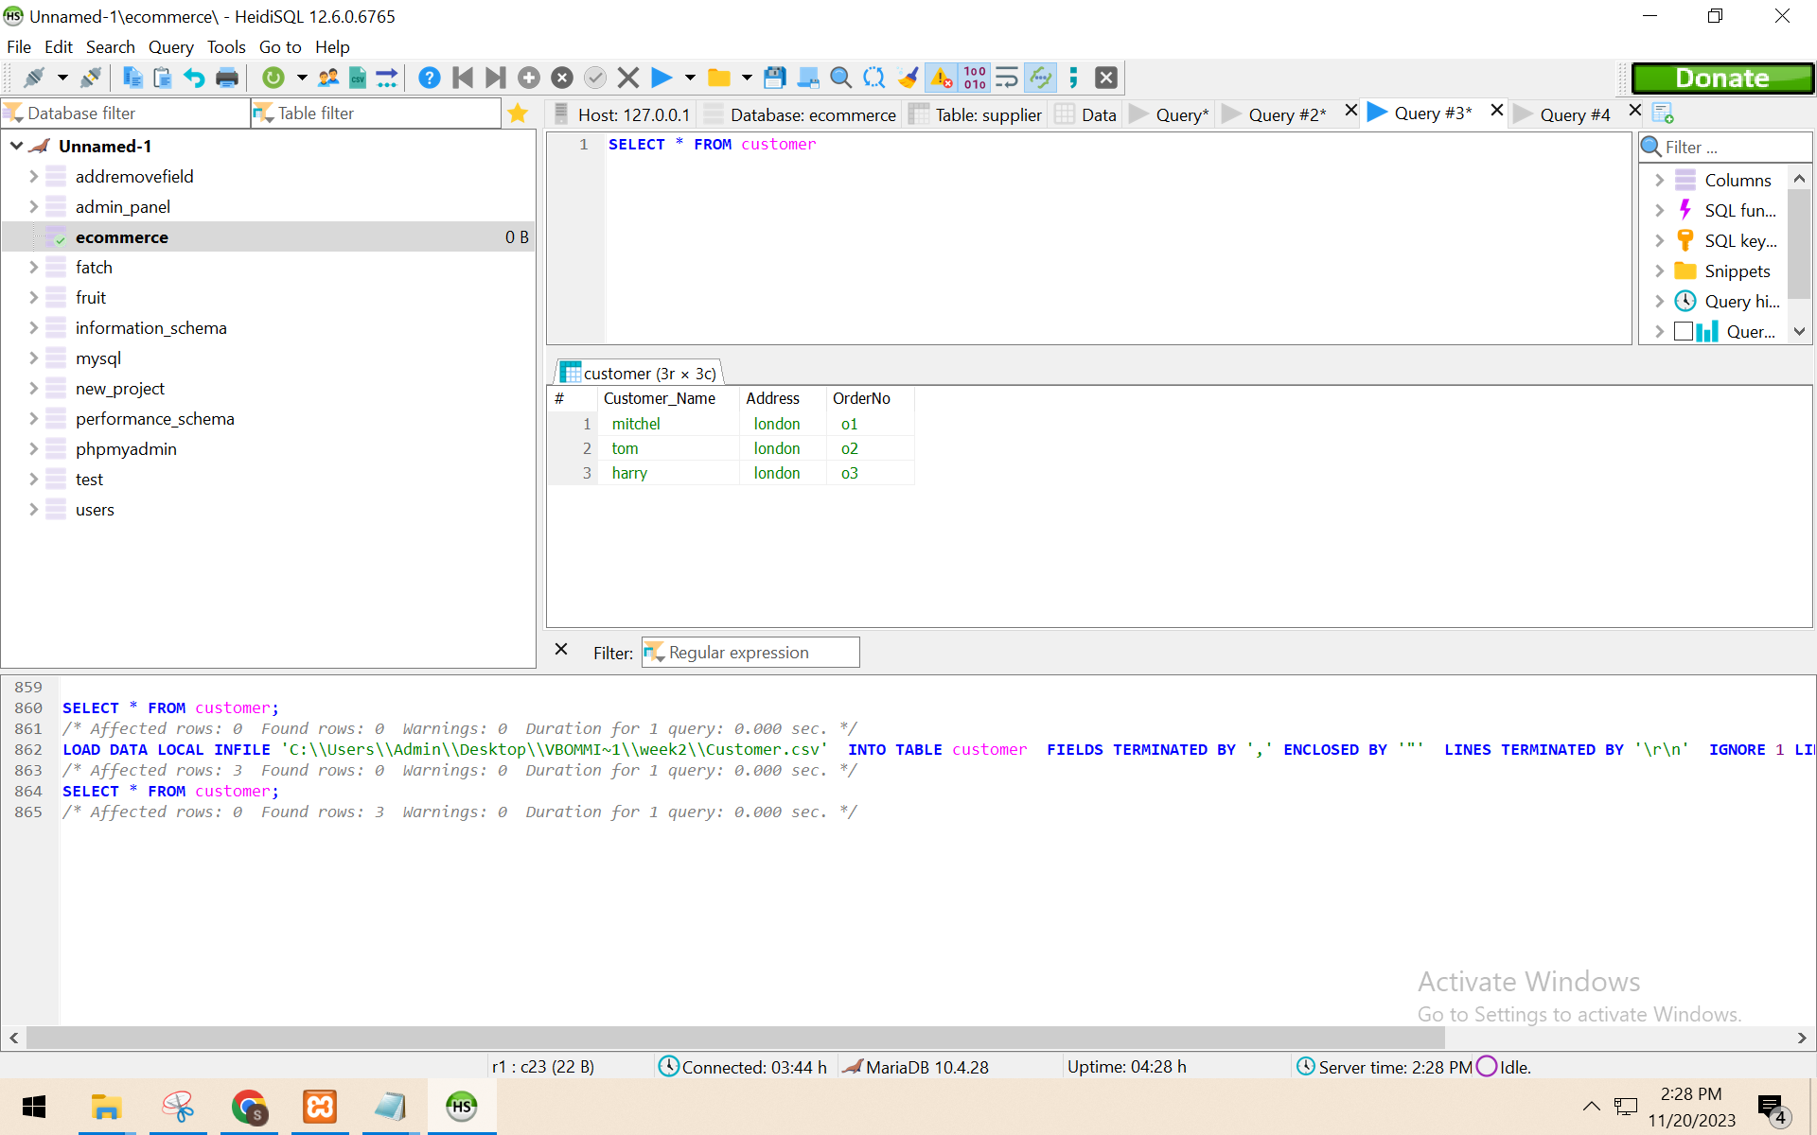

SELECT * FROM ordertable

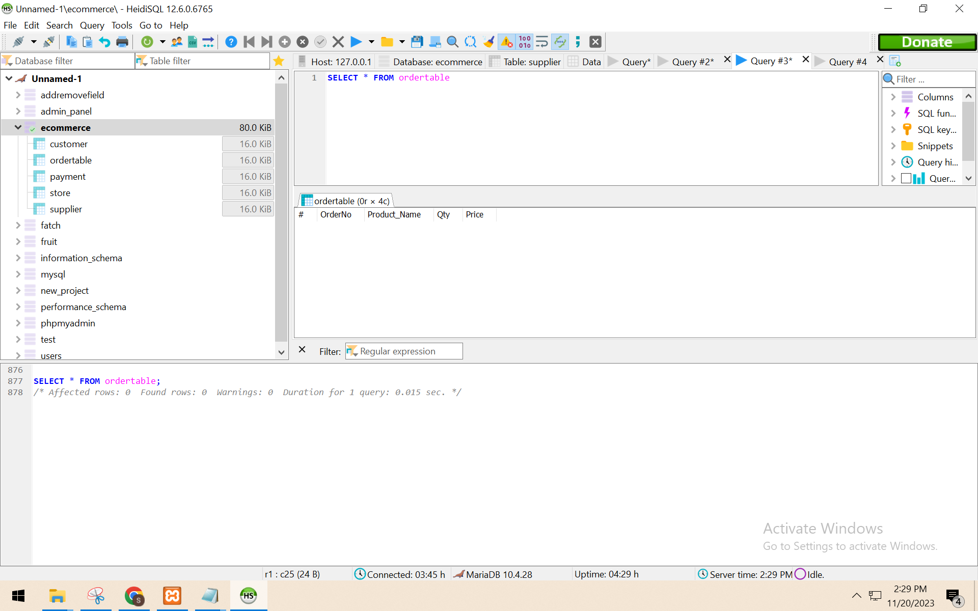

LOAD DATA LOCAL INFILE 'C:\\Users\\Admin\\Desktop\\VBOMMI~1\\week2\\Order.csv'

INTO TABLE ordertable

FIELDS TERMINATED BY ',' ENCLOSED BY '"'

LINES TERMINATED BY '\r\n'

IGNORE 1 LINES

(`OrderNo`, `Product_Name`, `Qty`,`Price`);

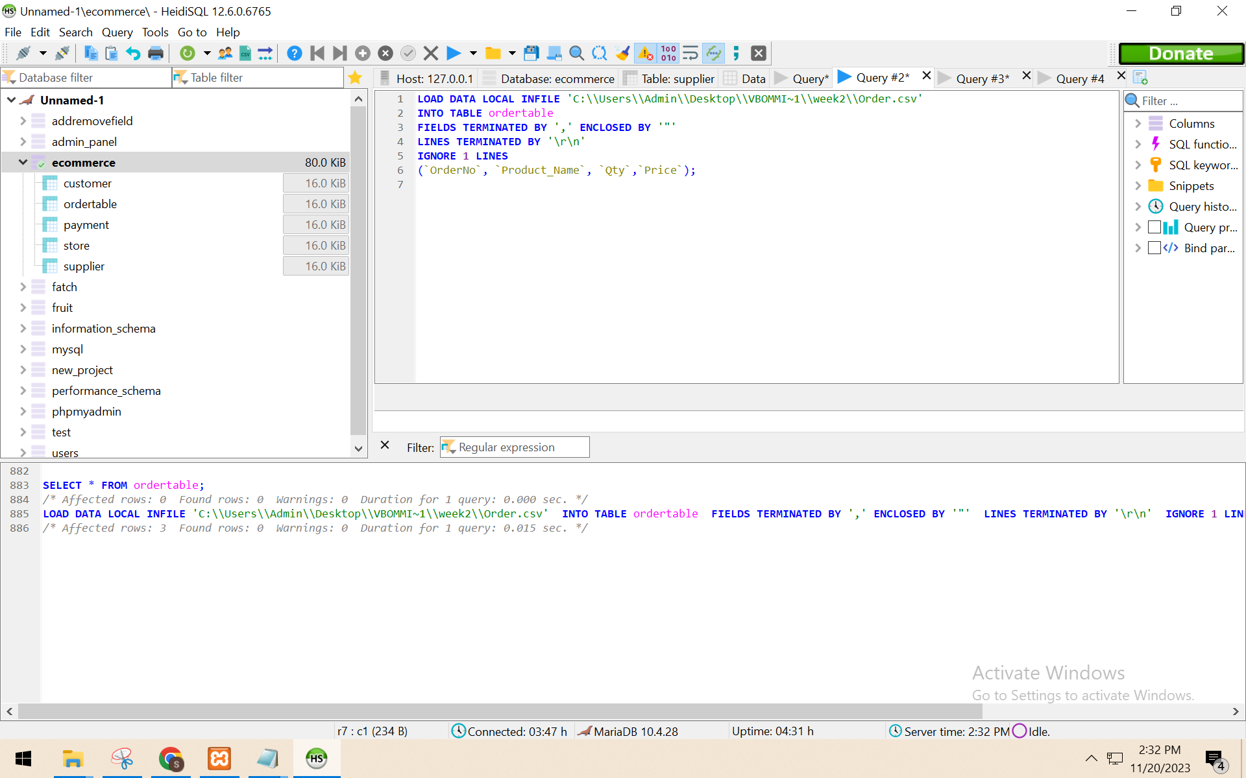

SELECT * FROM ordertable

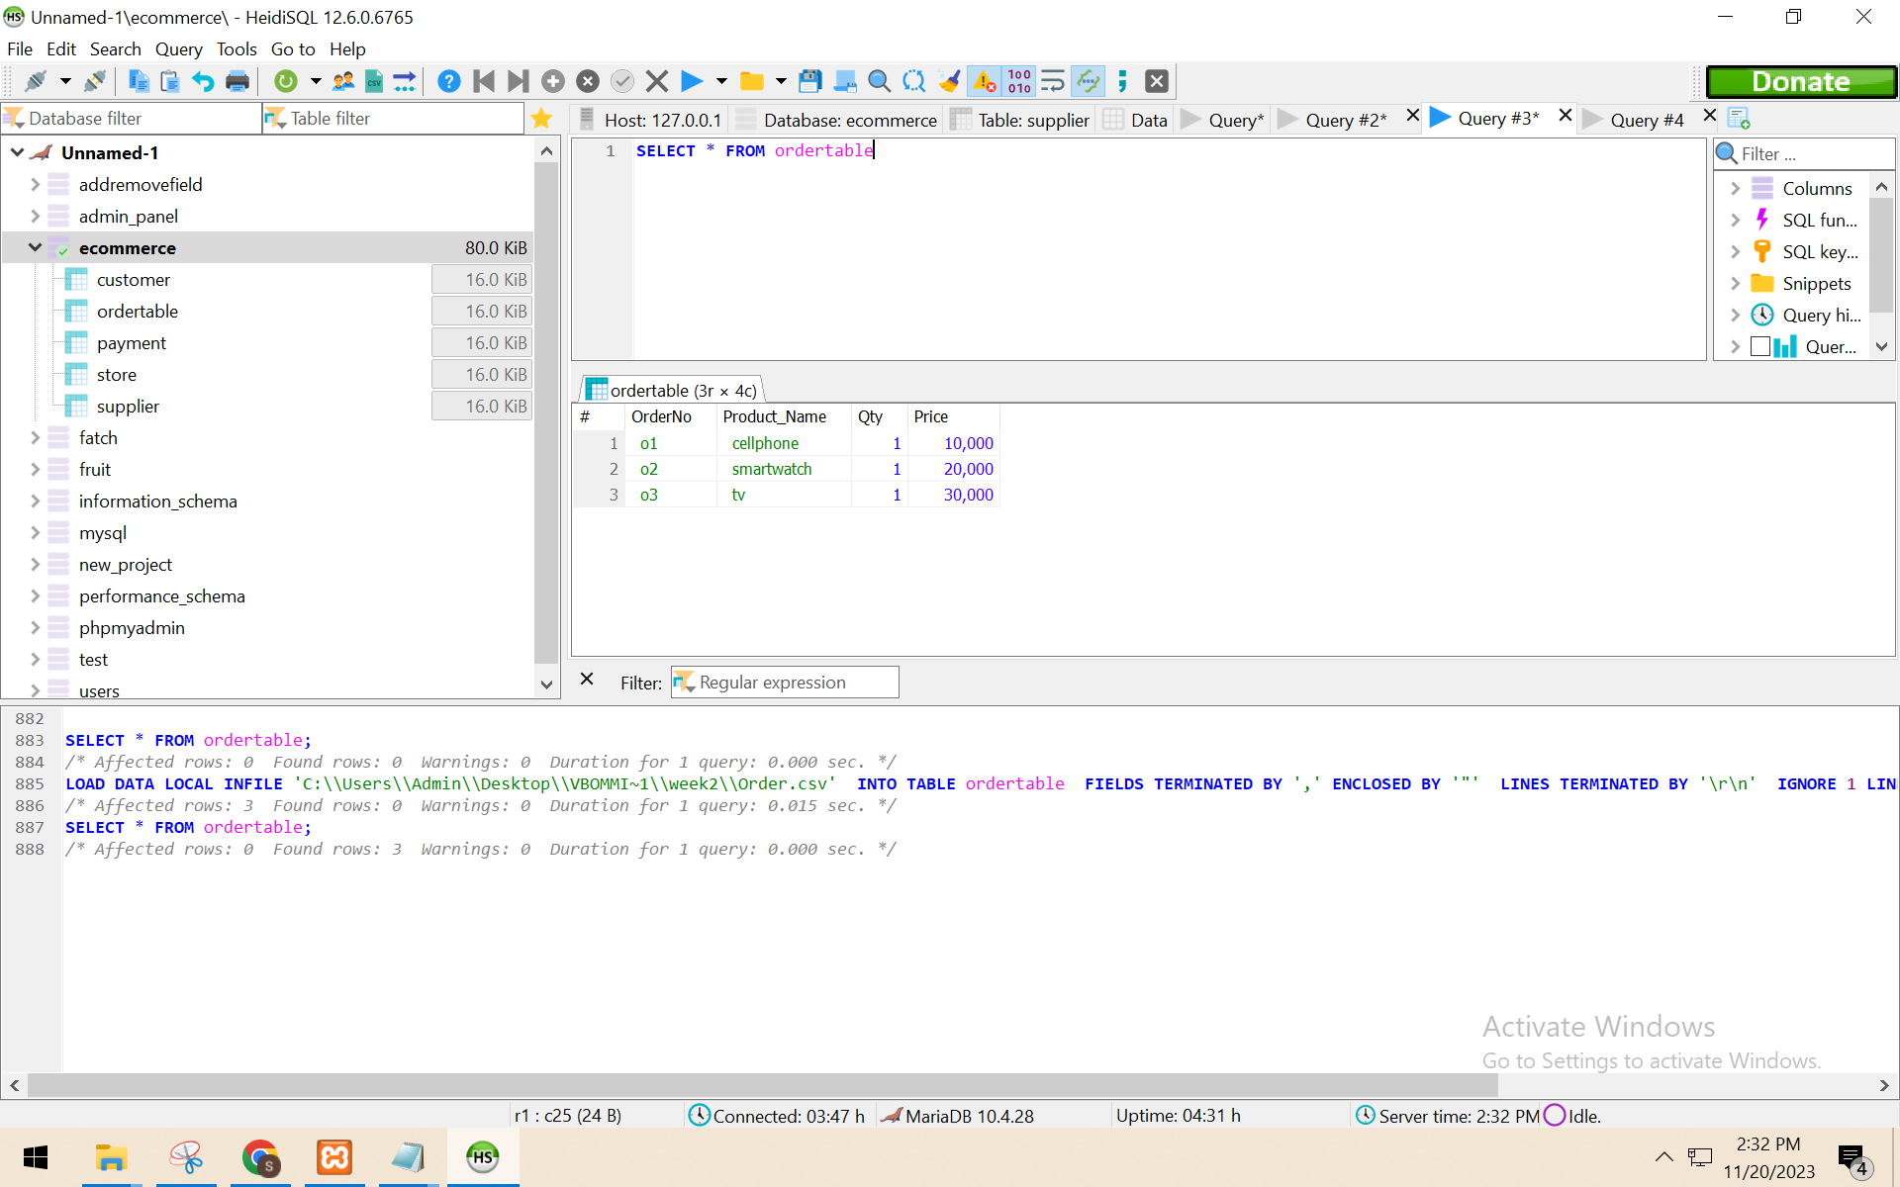

SELECT * FROM payment

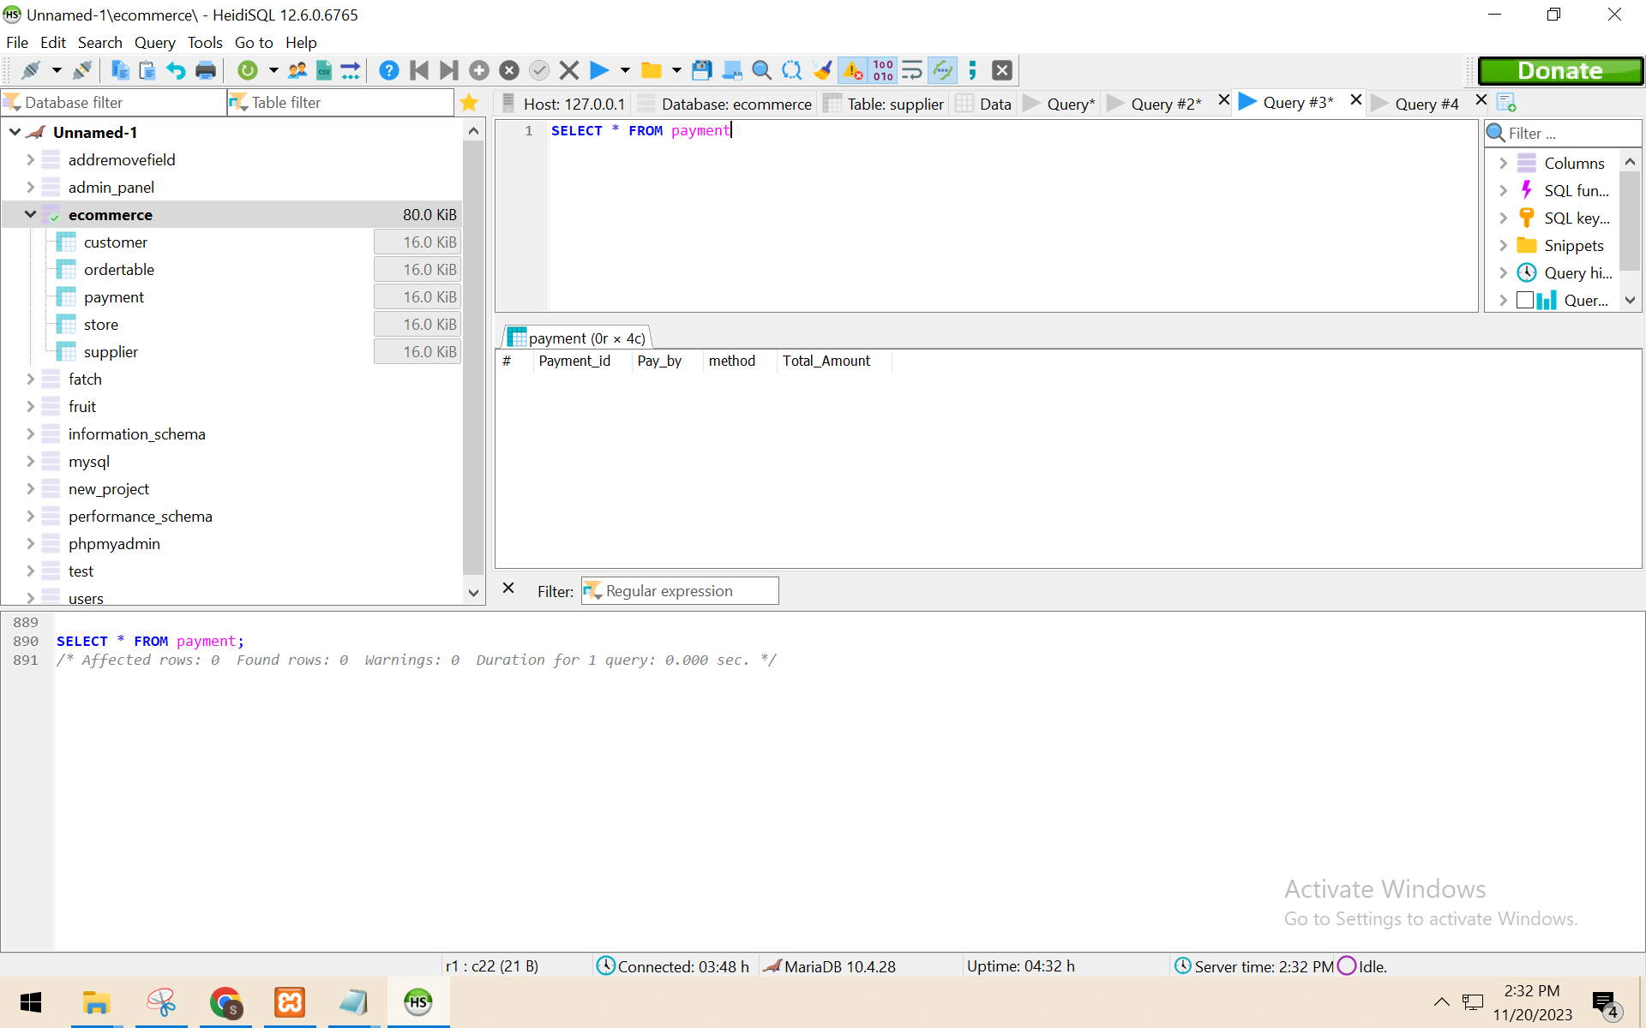

LOAD DATA LOCAL INFILE 'C:\\Users\\Admin\\Desktop\\VBOMMI~1\\week2\\Payment.csv'

INTO TABLE payment

FIELDS TERMINATED BY ',' ENCLOSED BY '"'

LINES TERMINATED BY '\r\n'

IGNORE 1 LINES

(`Payment_id`,`Pay_by`,`method`,`Total_Amount`);

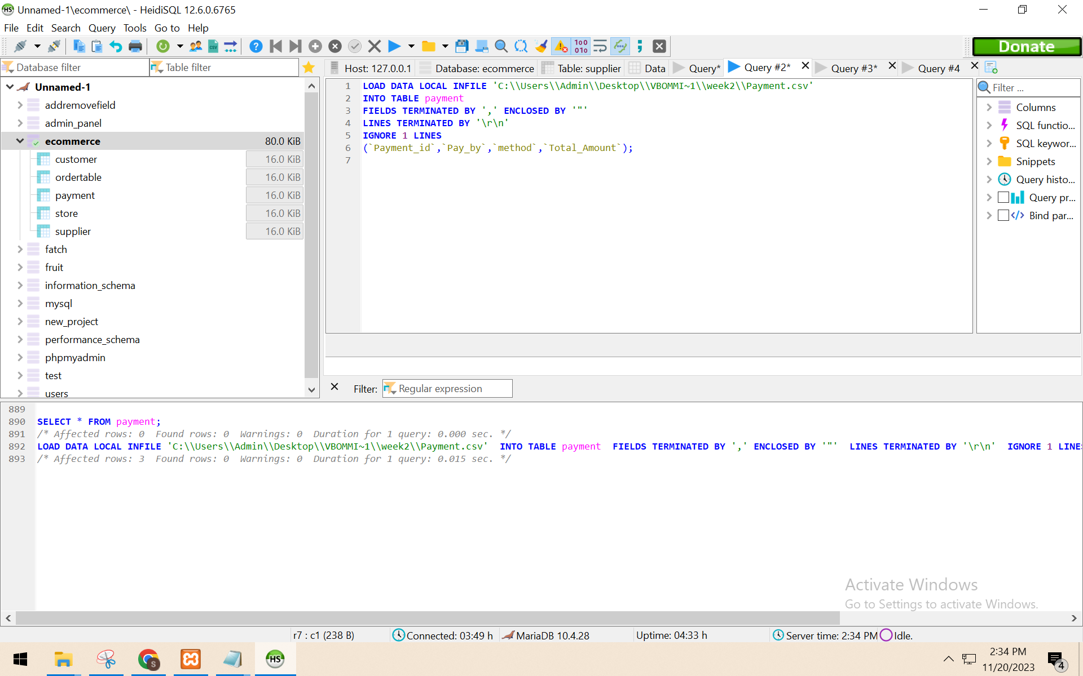

SELECT * FROM payment

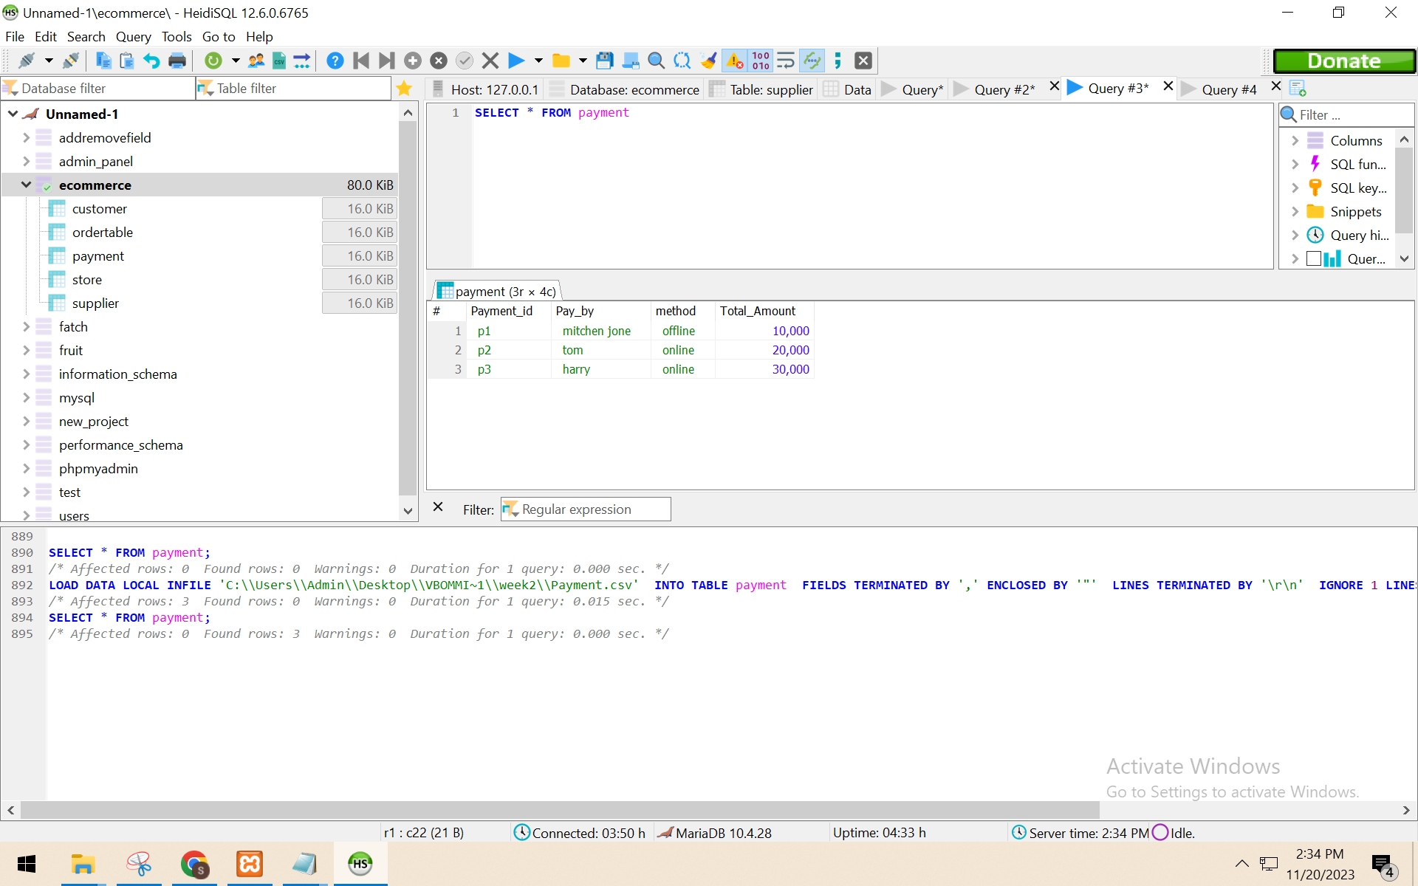

SELECT * FROM store

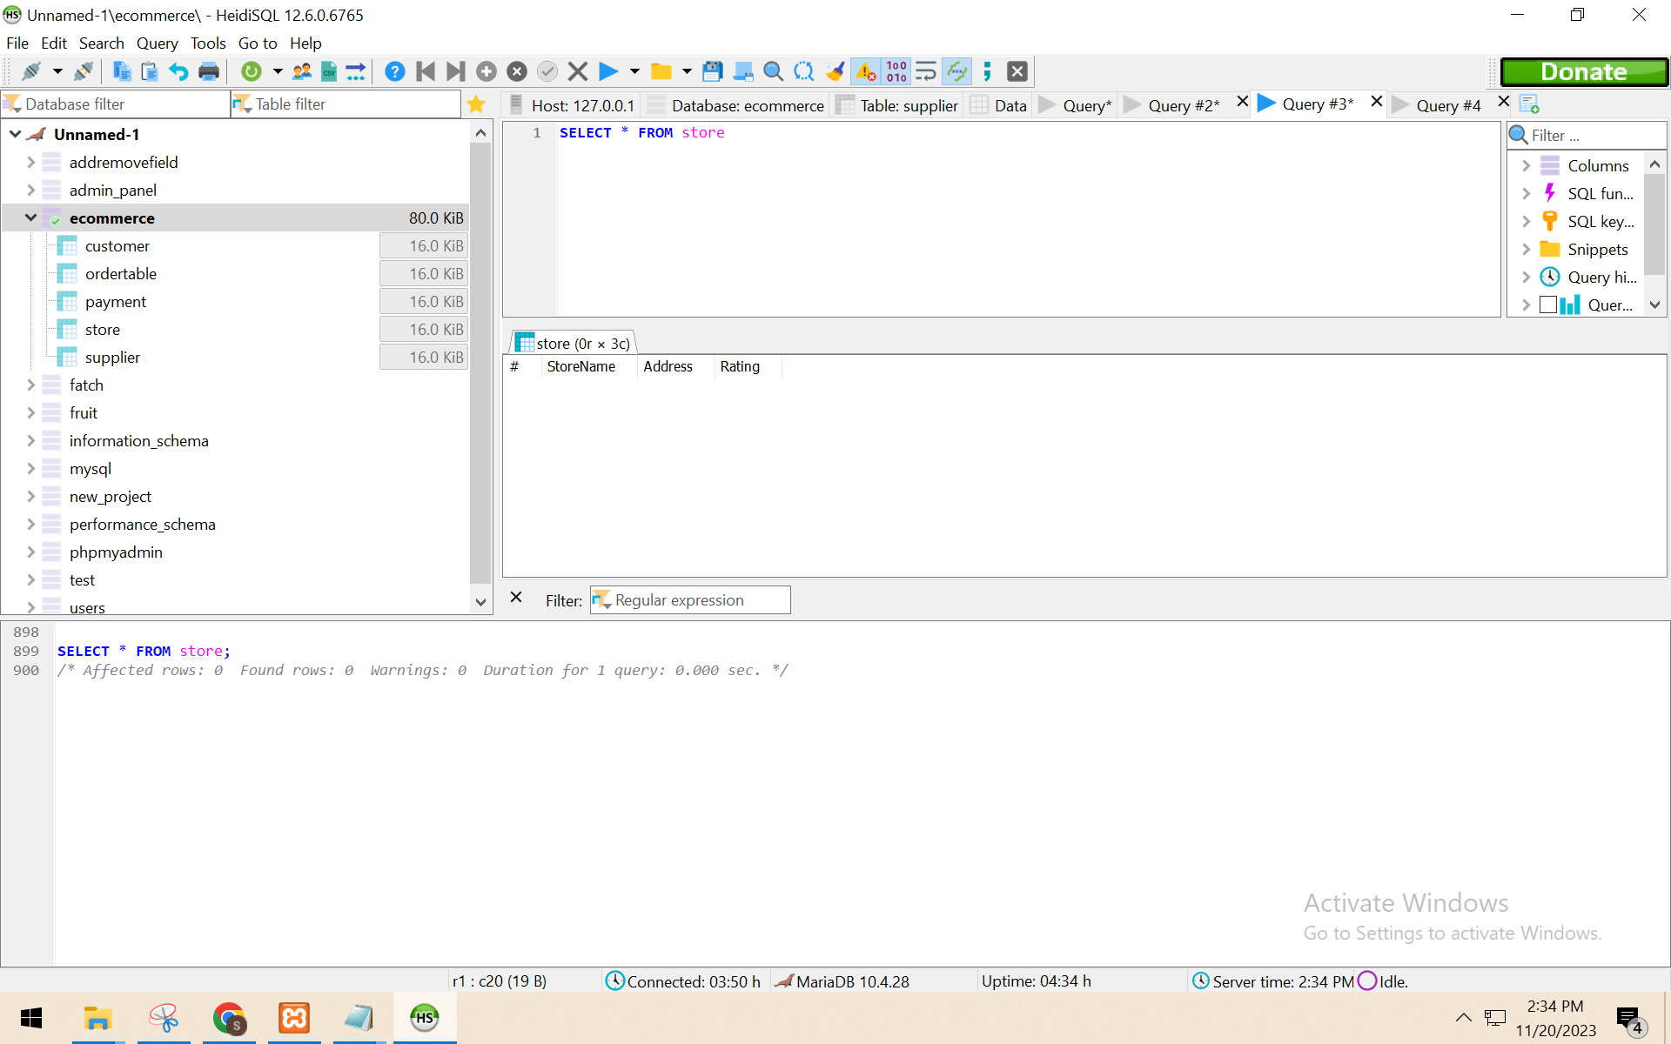

LOAD DATA LOCAL INFILE 'C:\\Users\\Admin\\Desktop\\VBOMMI~1\\week2\\Store.csv'

INTO TABLE store

FIELDS TERMINATED BY ',' ENCLOSED BY '"'

LINES TERMINATED BY '\r\n'

IGNORE 1 LINES

(`StoreName`,`Address`,`Rating`);

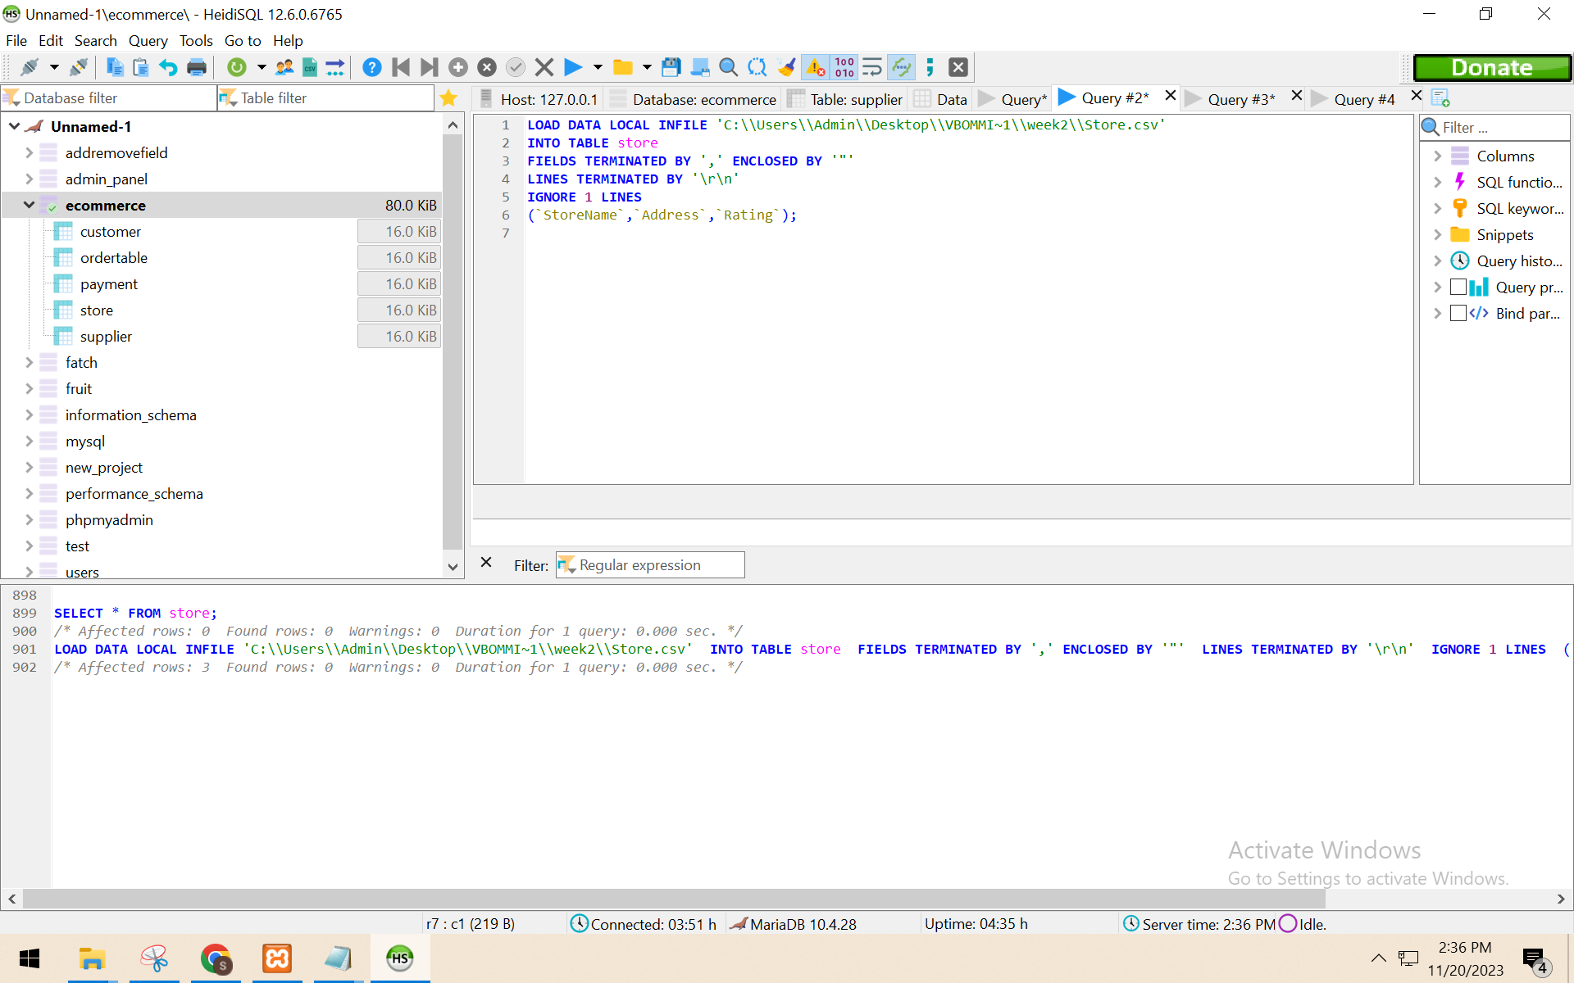

SELECT * FROM store

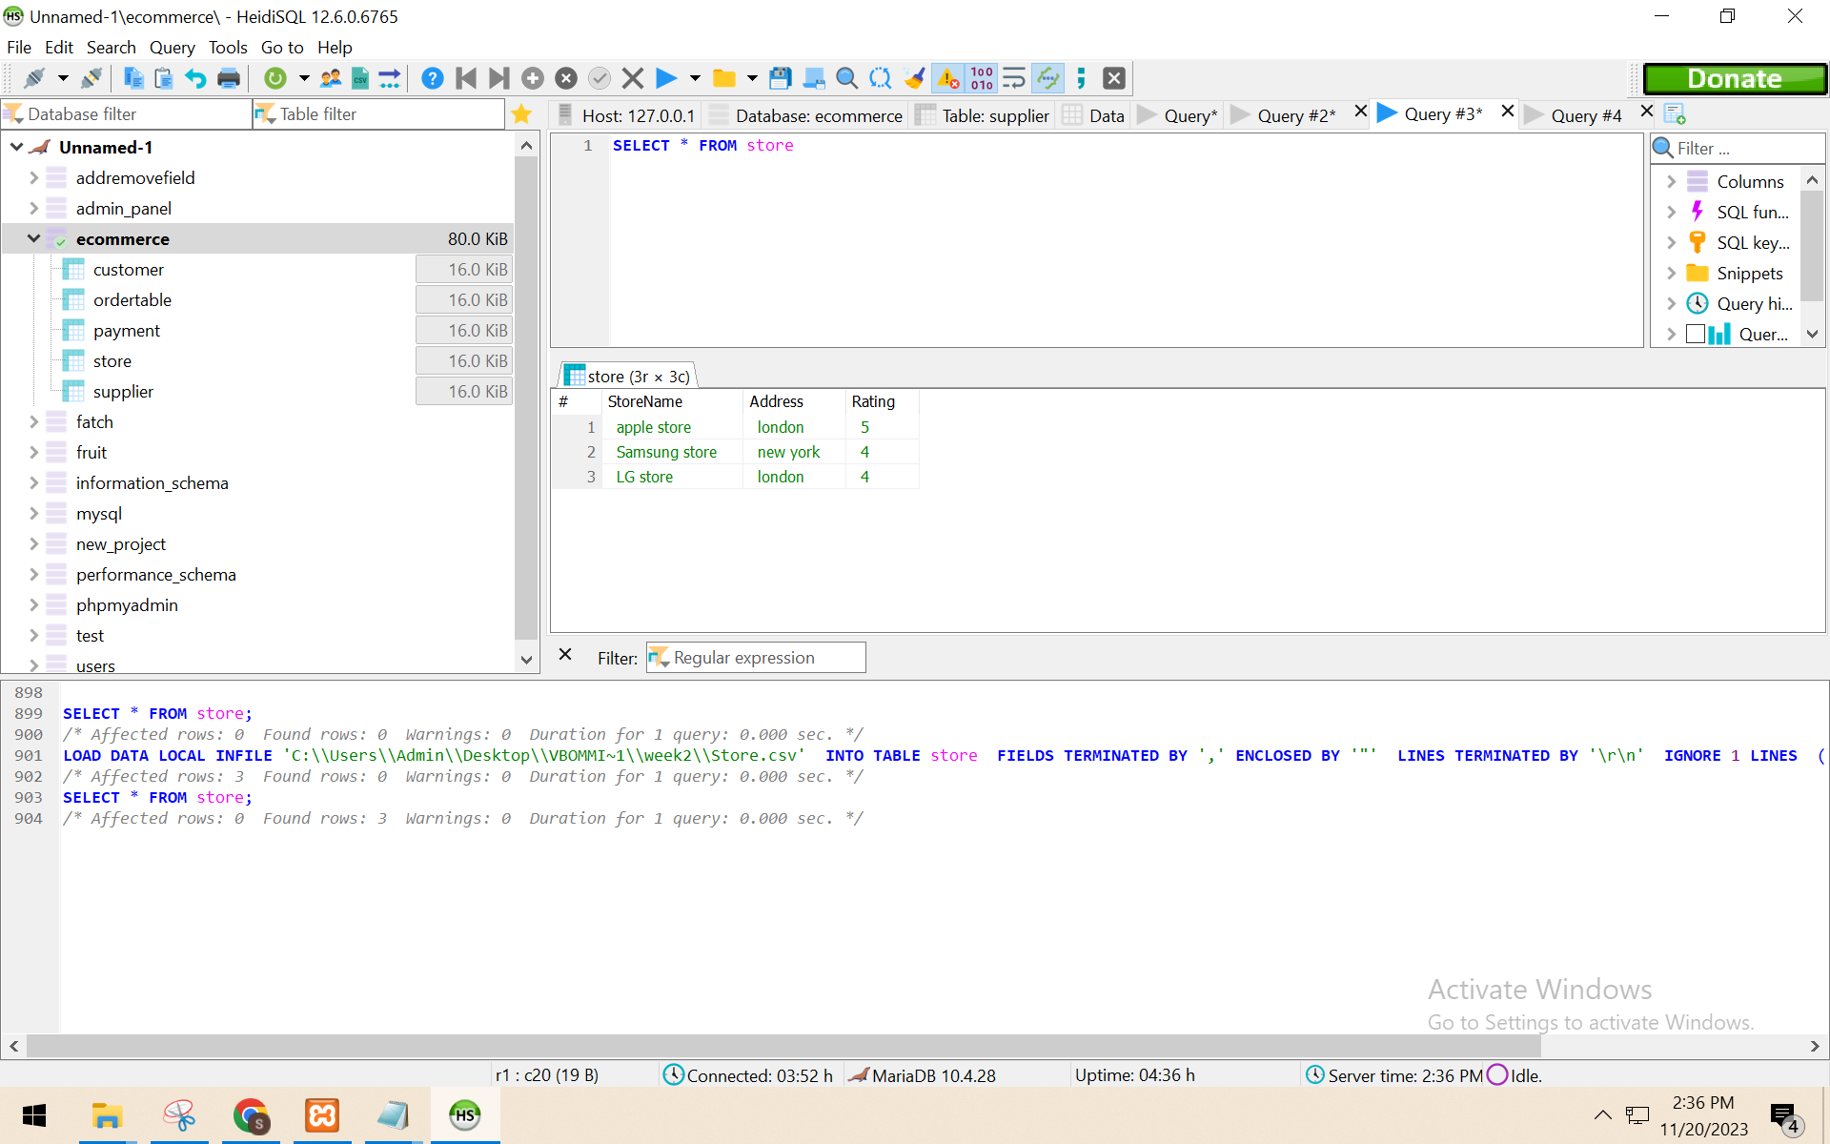

SELECT * FROM supplier

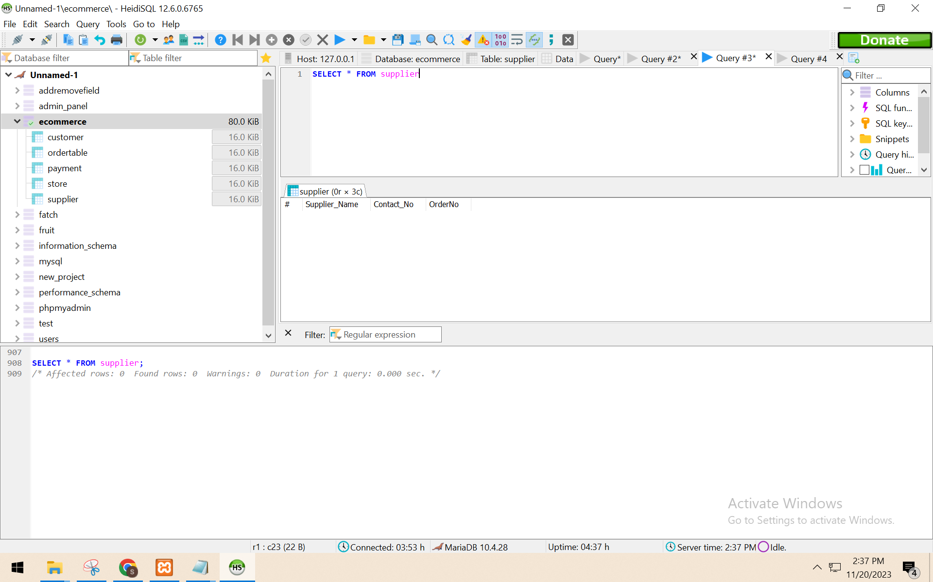

LOAD DATA LOCAL INFILE 'C:\\Users\\Admin\\Desktop\\VBOMMI~1\\week2\\Supplier.csv'

INTO TABLE supplier

FIELDS TERMINATED BY ',' ENCLOSED BY '"'

LINES TERMINATED BY '\r\n'

IGNORE 1 LINES

(`Supplier_Name`,`Contact_No`,`OrderNo`);

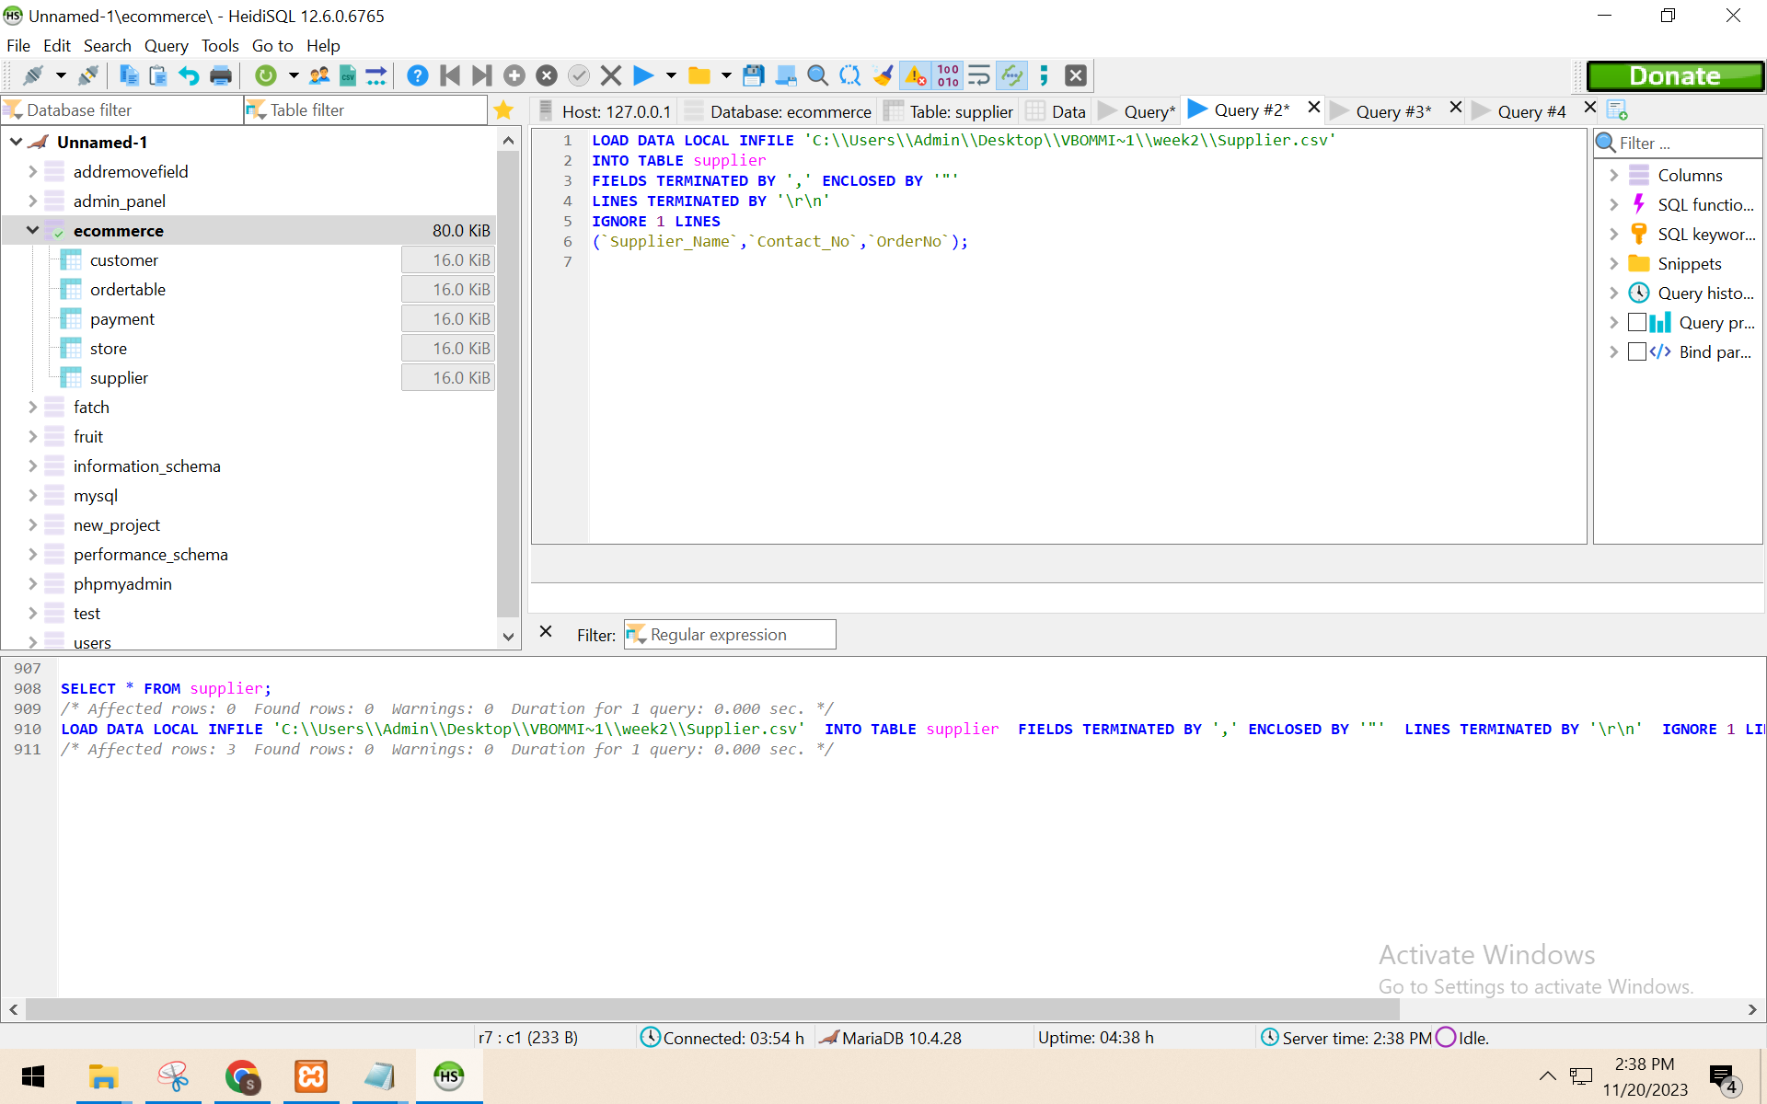

SELECT * FROM supplier

